***Dt : 6/9/2022***

***\*imp***

***Strings in Java:***

***=>The sequenced collection of characters which are represented***

***in double quotes is known as string.***

***Ex:***

***"nit","hyd","java",..***

***=>The characters in string are organized based on index values.***

***=>Strings in Java are not arrays.***

***=>The following pre-defined classes from java.lang package are***

***used to create string objects:***

***(1)java.lang.String class***

***(2)java.lang.StringBuffer class***

***(3)java.lang.StringBuilder class***

***(1)java.lang.String class:***

***=>The objects which are generated from 'java.lang.String' class***

***are "Immutable Objects".(The objects once created cannot be modified***

***are known as Immutable objects or Secured Objects or***

***Constant objects)***

***=>'String' class is holding 15 constructors.***

***=>we use the following two syntaxes to create 'String' class***

***Objects:***

***syntax-1 : using 'String literal process'.***

***String branch = "CSE";***

***String name = "Raj";***

***syntax-2 : Using 'new operator process'***

***String ob1 = new String("1234A1123");***

***String ob2 = new String("r@gmail.com");***

***================================================================***

***Ex-Program-1:***

***wap to read and display String?***

***DemoString1.java***

***package maccess;***

***import java.util.*;***

***public class DemoString1 {***

***public static void main(String[] args) {***

***Scanner s = new Scanner(System.in);***

***System.out.println("Enter the String:");***

***String str = s.nextLine();//String Literal process***

***int len = str.length();***

***System.out.println("====toString()====");***

***System.out.println(str);***

***System.out.println("length:"+len);***

***System.out.println("===display based on index====");***

***for(int i=0;i<=len-1;i++)***

***{***

***char ch = str.charAt(i);//retrieve char by index***

***System.out.print(ch+" ");***

***}//end of loop***

***System.out.println("\n====display in reverse using index====");***

***for(int i=len-1;i>=0;i--)***

***{***

***char ch = str.charAt(i);***

***System.out.print(ch+" ");***

***}//end of loop***

***s.close();***

***}***

***}***

***o/p:***

***Enter the String:***

***program***

***====toString()====***

***program***

***length:7***

***===display based on index====***

***p r o g r a m***

***====display in reverse using index====***

***m a r g o r p***

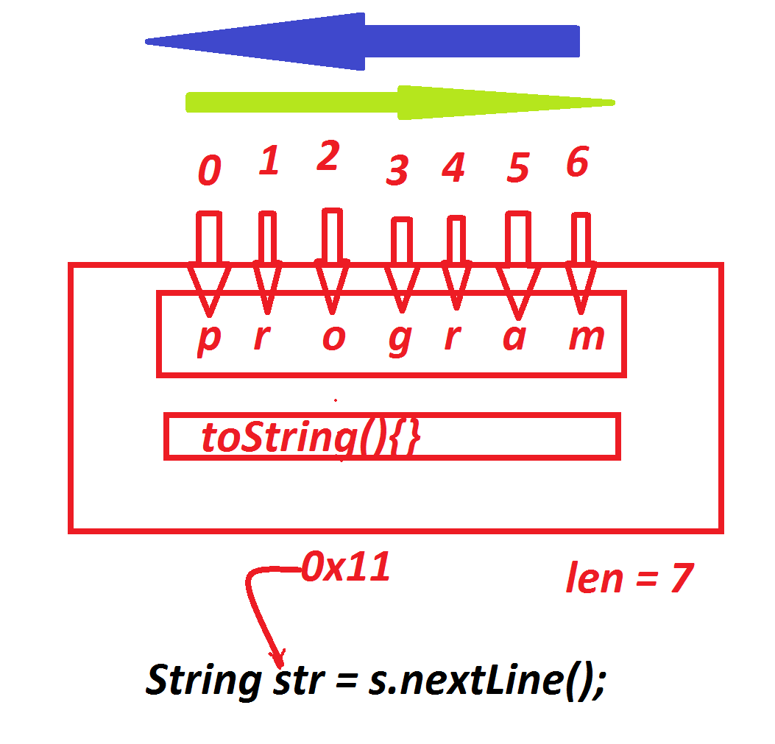

***========================================================***

***faq:***

***define charAt() method?***

***=>charAt() method is used to retrieve characters from the string***

***based on index values.***

***syntax:***

***char ch = str.charAt(index);***

***=========================================================***

***faq:***

***define toString() method?***

***=>toString() method is used to display the content from the object.***

***Method Signature:***

***public java.lang.String toString();***

***syntax:***

***String data = str.toString();***

***Note:***

***=>toString() method is auto-executable method and which is executed***

***automatically when we display object_ref_variable.***

***==========================================================***

***Assignment-1:***

***wap to read a String and display the count of Vowels from the String?***

***I/P : program***

***O/P : count = 2***

***Assignment-2:***

***wap to read a String and check the String is palindrome String or***

***not?***

***================================================================***